







UID /home/

ReadySetResource.com

Contents

7.1 - Home 3

7.2 - Our Story 4

7.3 - Solutions 5

7.4 - Log In 6

7.5 - Forgot Password 7

7.6 - Create New Password 8

7.7 - Security Questions 9

7.8 - Job Opportunities 10

7.9 - Credits 11

7.10 - Site Map 12

7.11 - Two-Factor Authentication 13

7.12 - UID /home/ Work Log 14

# 7.1 - Home

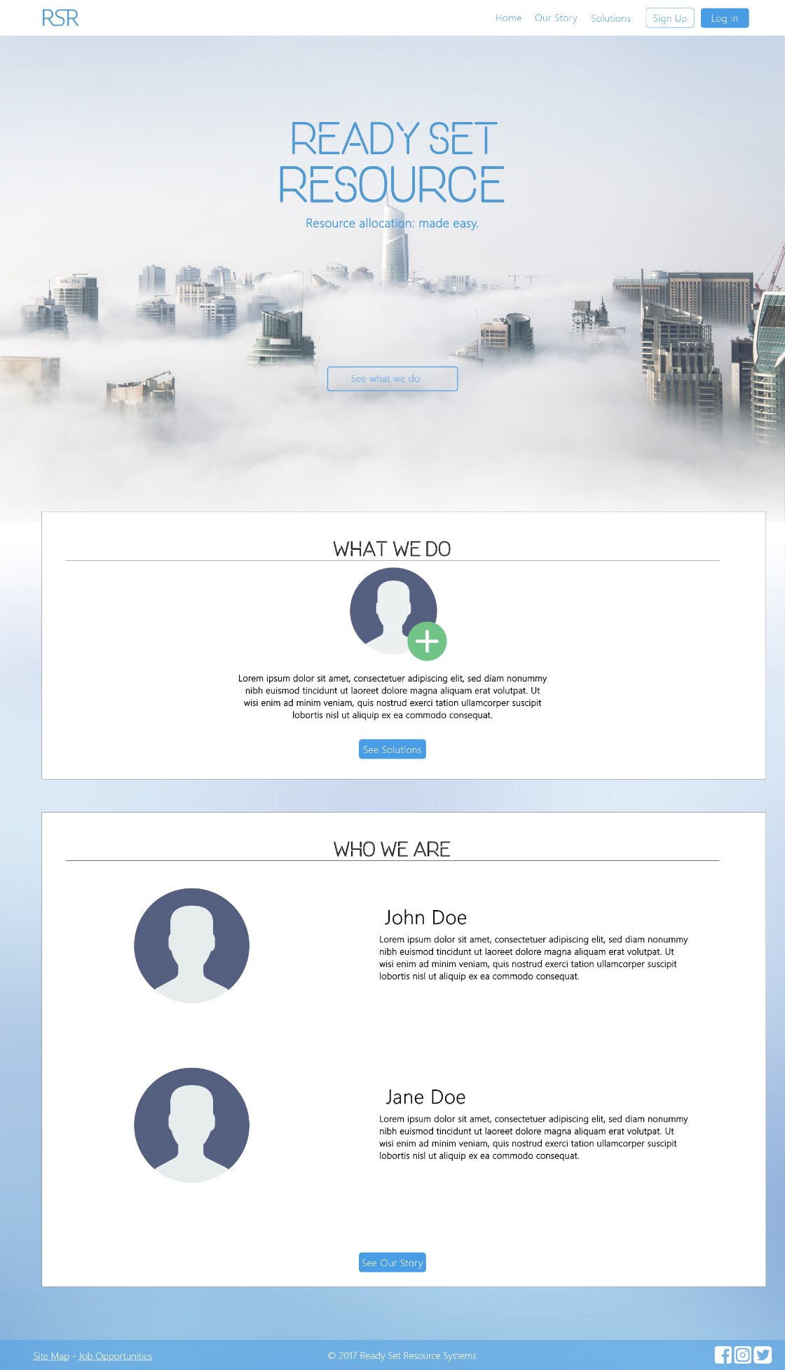

Input Permissible: None

Error Messages: None

# 7.2 - Our Story

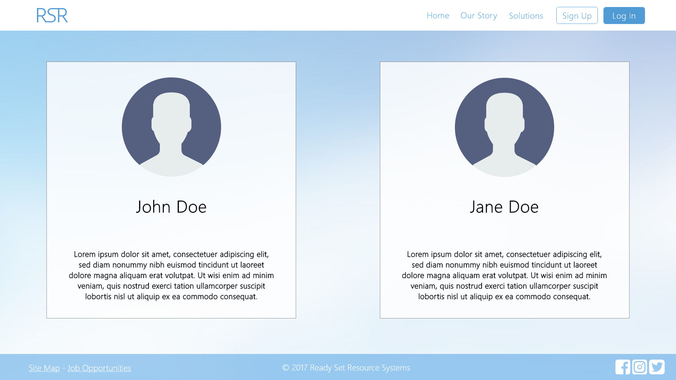

Input Permissible: None

Error Messages: None

# 7.3 - Solutions

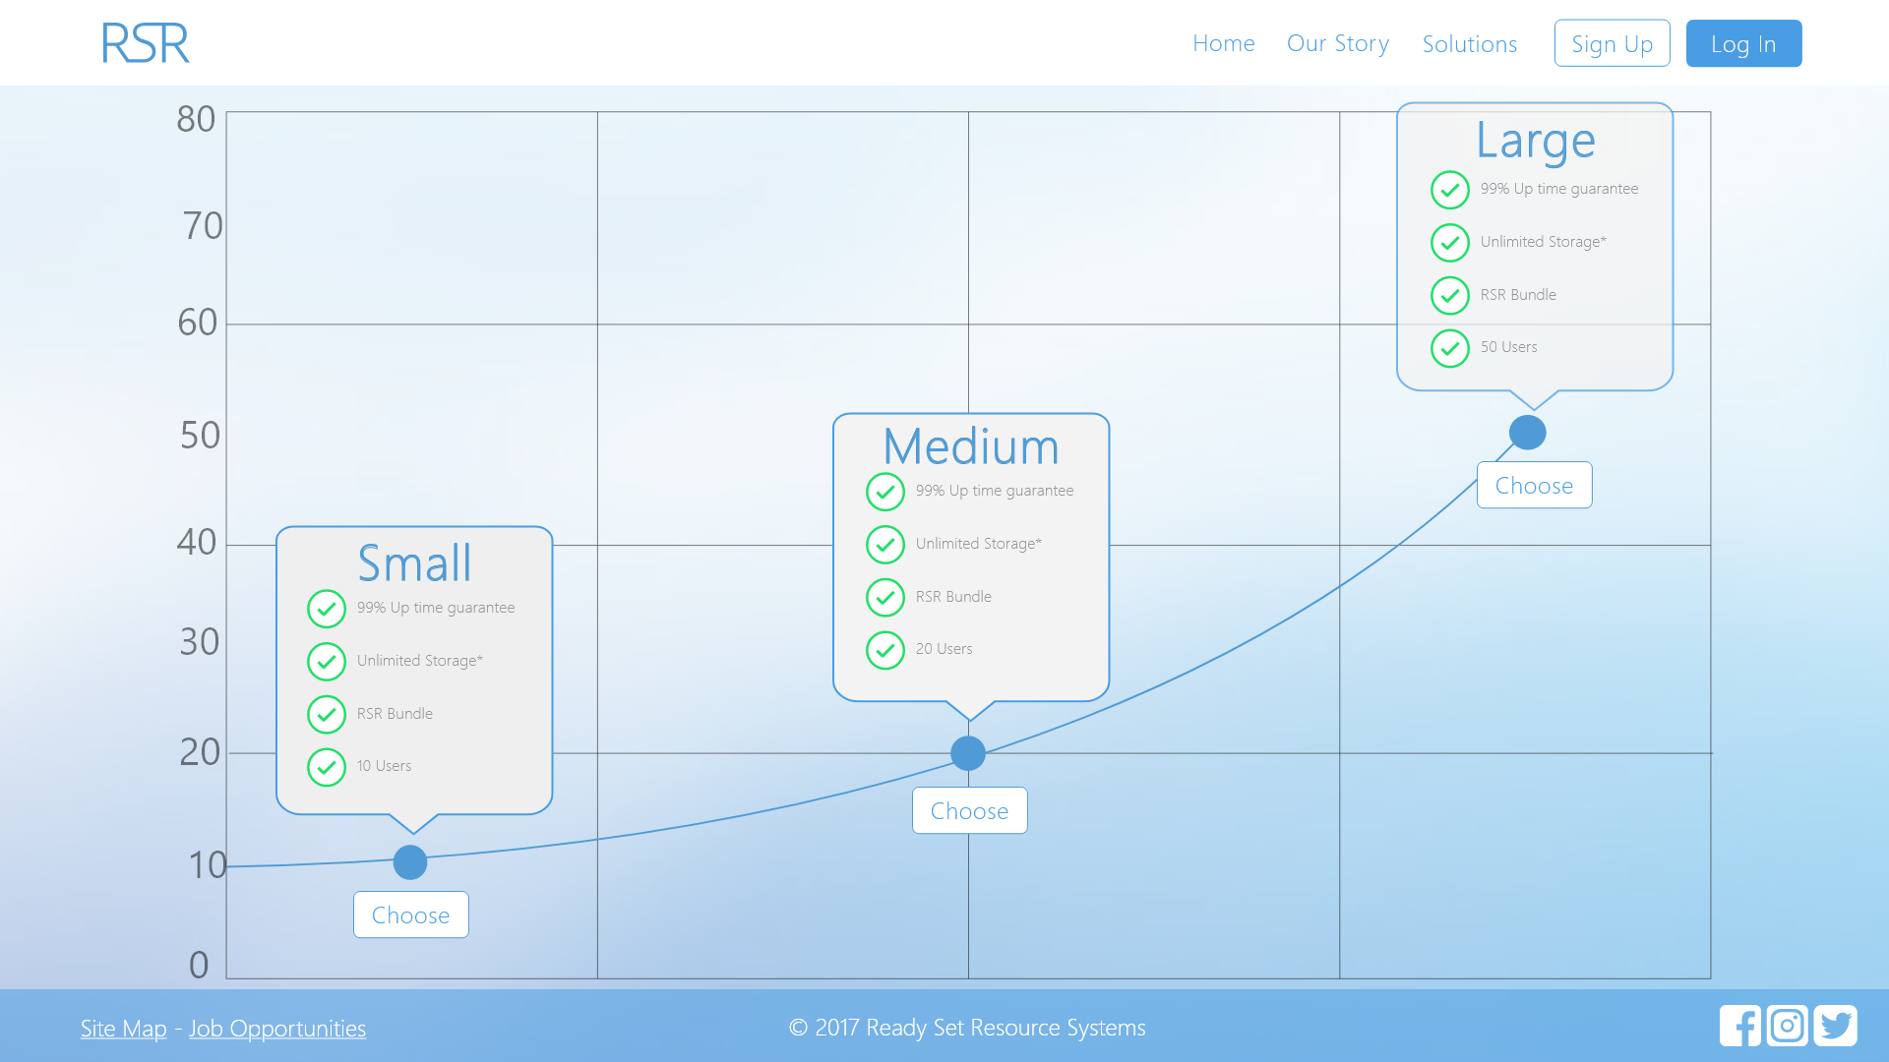

Input Permissible: None

Error Messages: None

# 7.4 - Log In

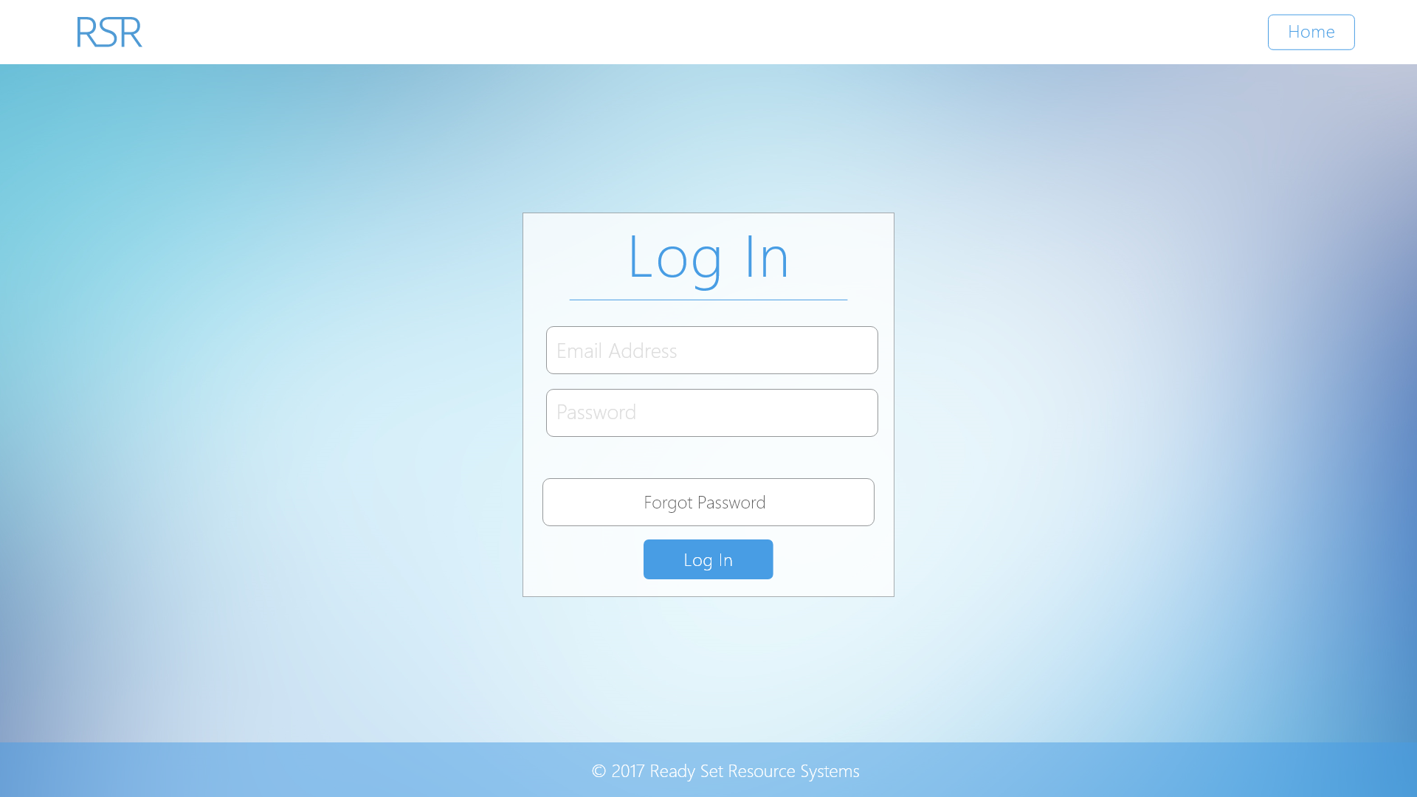

Input Permissible: - Email Address

- Password

Error Messages: - ‘That email address does not exist on our system.’

- ‘Your password is incorrect.’

- ‘You have been locked out. Please contact our experts for help.’

# 7.5 - Forgot Password

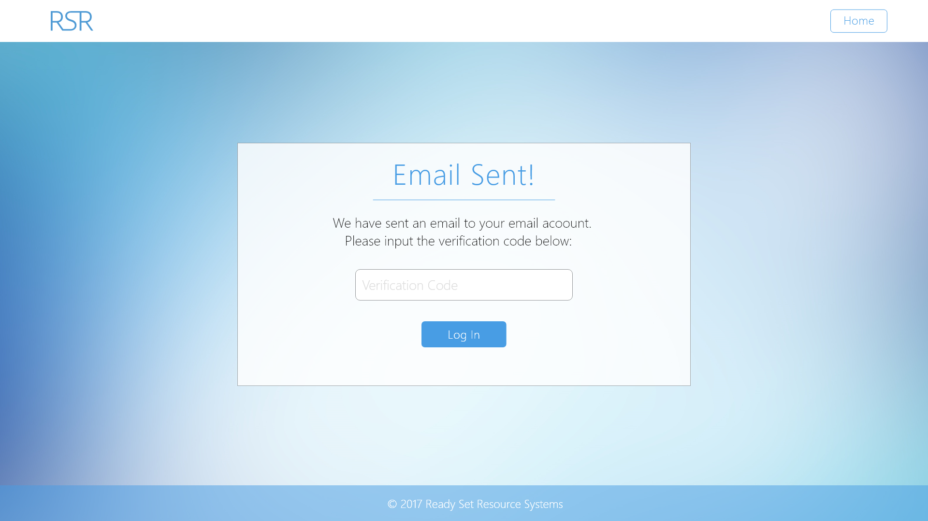

Input Permissible: - Verification Code

Error Messages: - ‘That verification code is incorrect’

- ‘You have tried too many wrong combinations’

# 7.6 - Create New Password

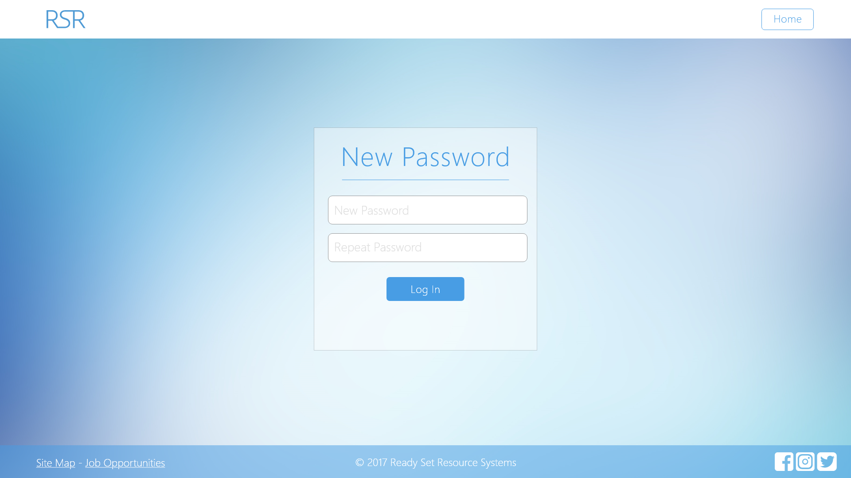

Input Permissible: - Password

Error Messages: - ‘Password must be at least 8 characters’

- ‘Password must contain an uppercase letter’

- ‘Password must contain a lowercase letter’

- ‘Password must contain a number’

# 7.7 - Security Questions

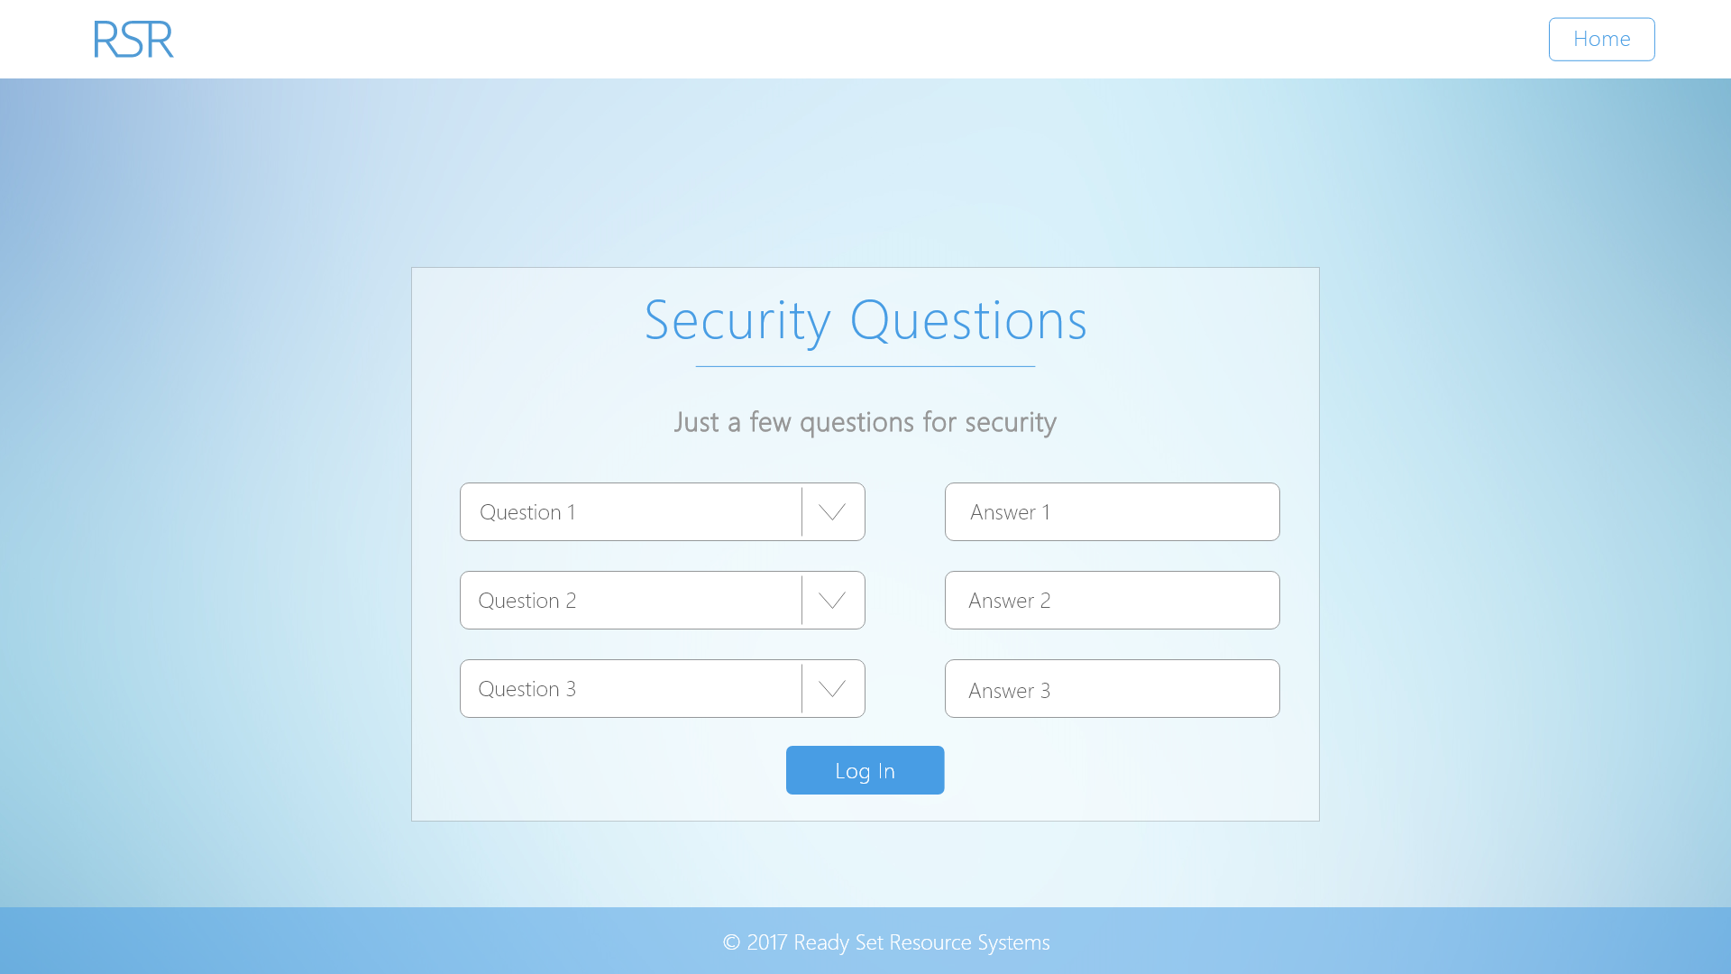

Input Permissible: - 3 Answers (strings)

Error Messages: - ‘Answer (ANSWER NUMBER) must not be longer than 20 characters’

# 7.8 - Job Opportunities

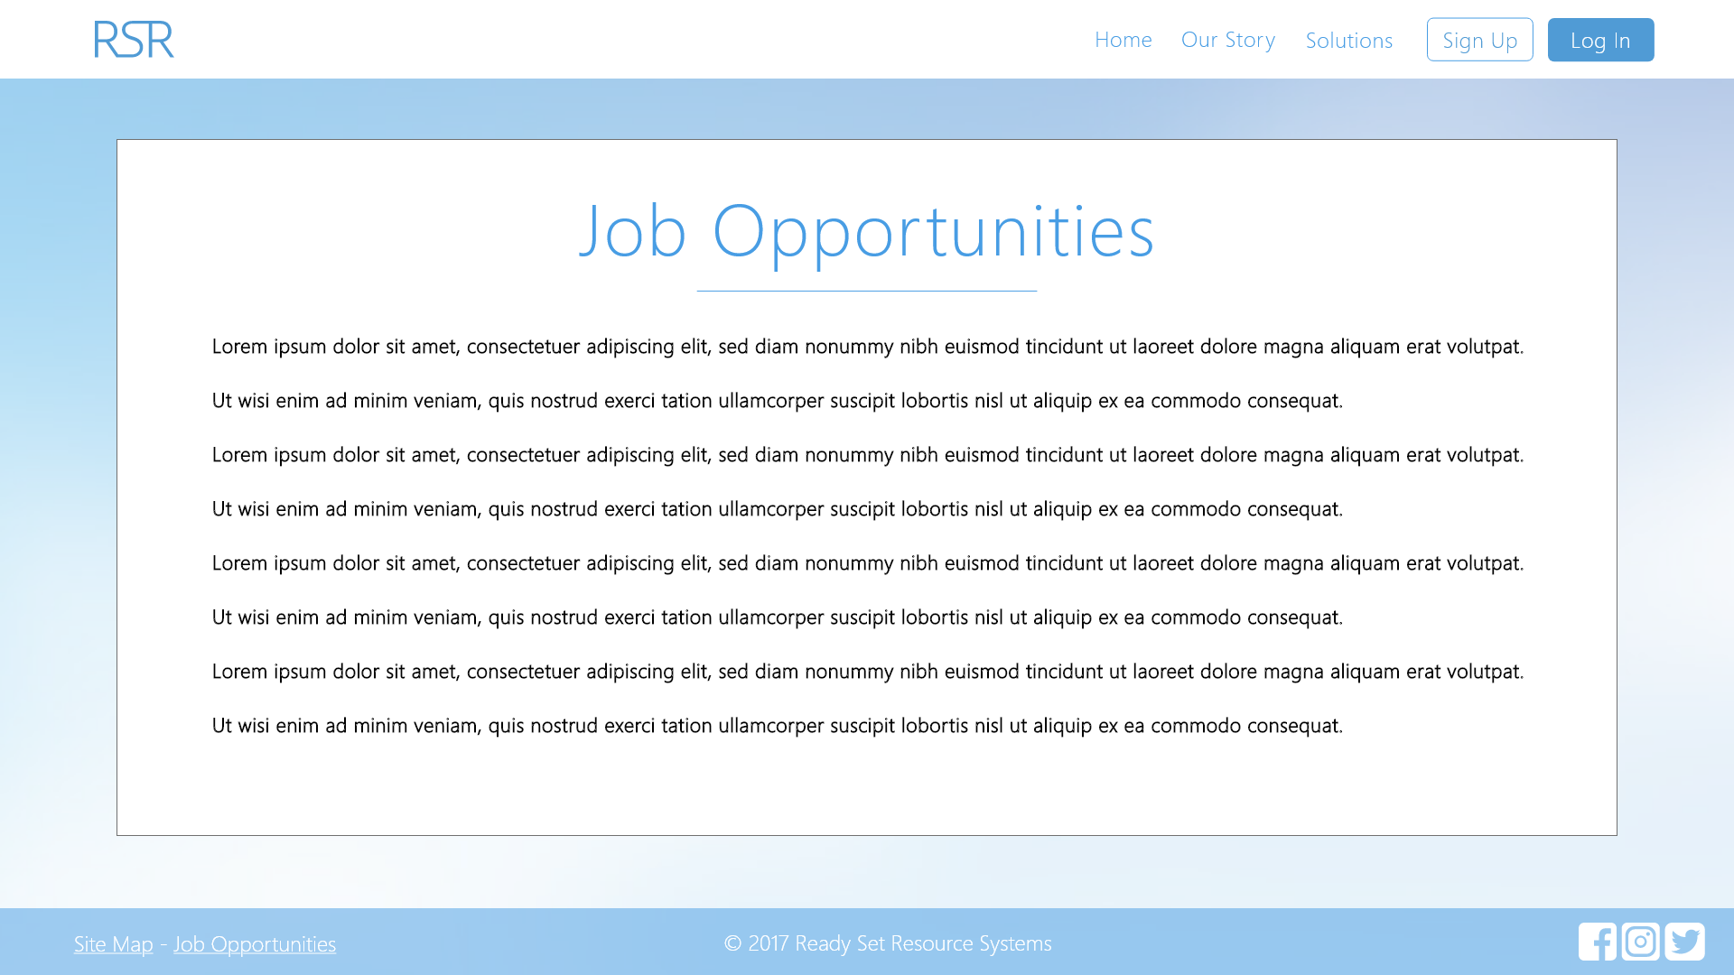

Input Permissible: None

Error Messages: None

# 7.9 - Credits

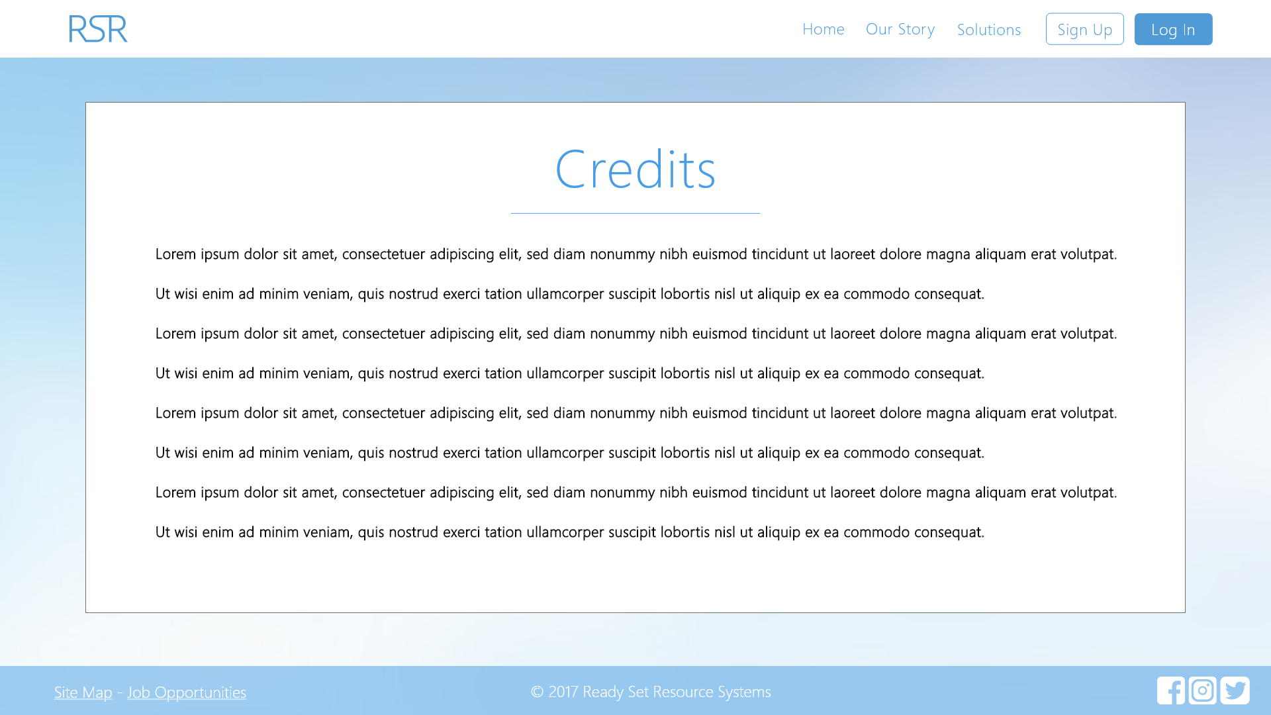

Input Permissible: None

Error Messages: None

# 7.10 - Site Map

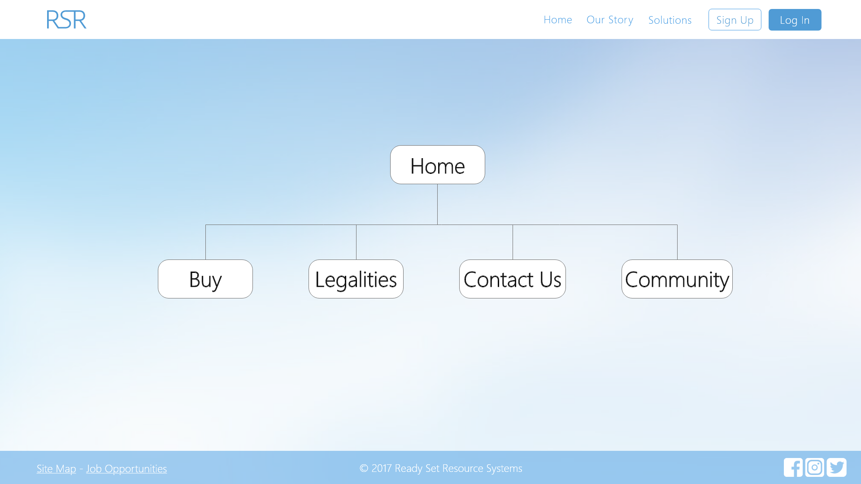

Input Permissible: None

Error Messages: None

# 7.11 - Two-Factor Authentication

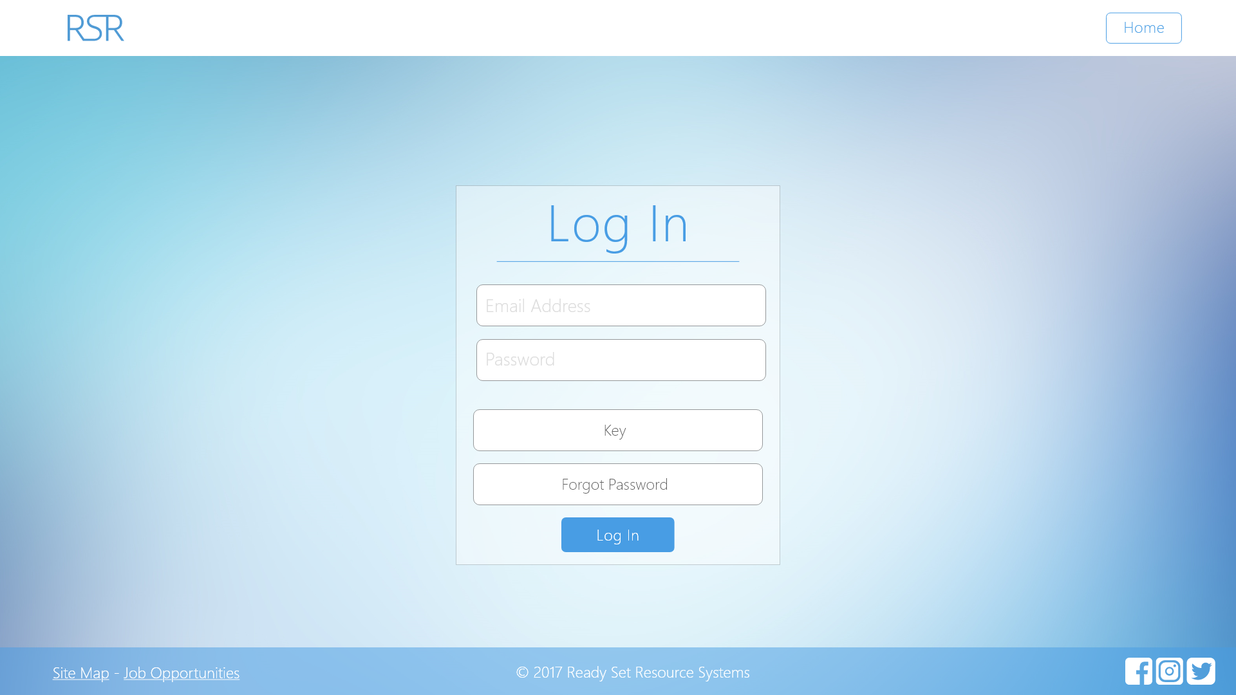

Input Permissible: - Password

Error Messages: - ‘Password must be at least 8 characters’

- ‘Password must contain an uppercase letter’

- ‘Password must contain a lowercase letter’

- ‘Password must contain a number’

- ‘Key is incorrect’

# 7.12 - UID /home/ Work Log

| Entry | Description | Person | Date | Mins Spent |
| --- | --- | --- | --- | --- |
| 1 | Formatted the document | Aidan Marshall | 19/3/18 | 12 |
| 2 | Designed the website | Aidan Marshall | 7/10/17 | 267 |
| 3 | Added screenshots and page details | Aidan Marshall | 7/10/17 | 21 |
| 300 | | | | |